

DATA STRUCTURES

REPORT

[15-12-2023]

Contents

[Group Members: 3](#_Toc135345294)

[Project Topic: 3](#_Toc135345295)

[Project Description: 4](#_Toc135345296)

[Components Required: 4](#_Toc135345297)

[Class Diagram: 5](#_Toc135345298)

[Simulation Results: 6](#_Toc135345299)

[7](#_Toc135345300)

[Procedure Followed: 8](#_Toc135345302)

# Group Members:

* Muhammad Umar Saleem (22i-0951)
* Hamza Naveed (22i-0961)
* Abdul Momin Abbasi (22i-1326)  
    
  Project Topic:

IPFS SYSTEM

# Project Description:

# In this project, we were required to implement a special type of Distributed Hash Table (DHT) called Ring DHT using C++ in Visual Studio 2022. The Ring DHT uses a 160-bit circular identifier space and is responsible for storing and retrieving data (IPFS files) across multiple machines geo-distributed across the internet. Our implementation has allowed for the configuration of the identifier space size, support the addition and removal of machines without disrupting the functionality of the Ring DHT, and provide options to insert and remove files, print the routing table of any machine, and display the complete path taken by requests. Additionally, we have submitted a well-documented code and a document highlighting the design in terms of relationships/associations between different classes of your program.

# Components Required:

Following Libraries have been used in the making of project:

* CryptoPP library (for SHA-1)
* Iostream library
* Fstream library
* String library
* Sstream library
* Filesystem library
* Cstdio library
* Queue library
* Math.h library
* Thread library
* Chrono library
* BigInt (Self Implementation)

# Class Diagram:

# C:\Users\hamza\AppData\Local\Packages\5319275A.WhatsAppDesktop_cv1g1gvanyjgm\TempState\A34335A3BEDE0F17A7AF733B697AD848\WhatsApp Image 2023-12-15 at 18.08.40_0fa52d52.jpg

# Simulation Results:

*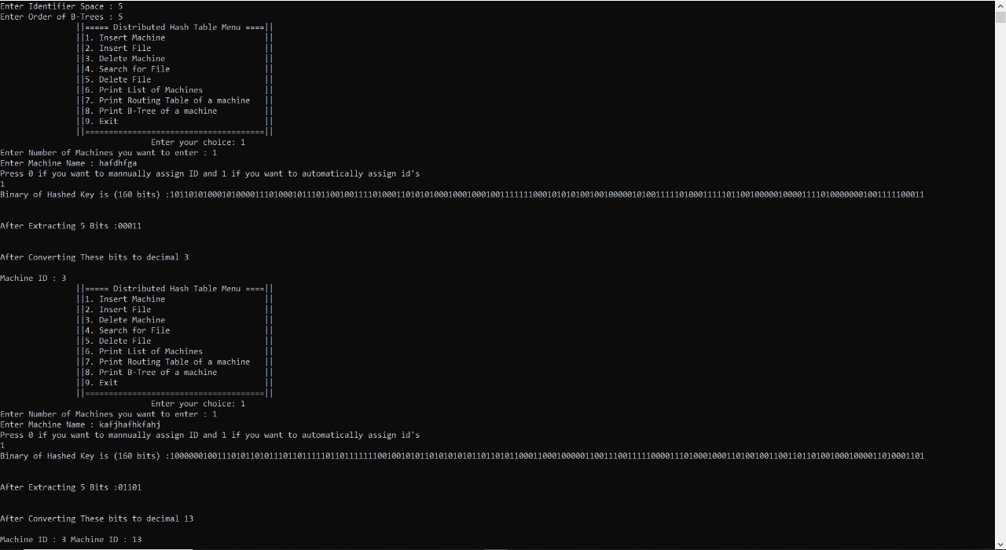*

# C:\Users\hamza\AppData\Local\Packages\5319275A.WhatsAppDesktop_cv1g1gvanyjgm\TempState\E1335D95CB3B93D835EB22780BE7327F\WhatsApp Image 2023-12-15 at 19.53.00_f255abfd.jpg

# Procedure Followed:

* We are making a Ring Distributed Hah Table
* Then we are taking input from the user of the identifying space and order
* Then we take input how many machine we add in the RDHT
* Then we are adding the machines according to the requirements
* Then we are displaying the menu
* Then we are taking choice as input from the user
* And then performing the relative operation as follows:  
  